Beef Stew Recipe

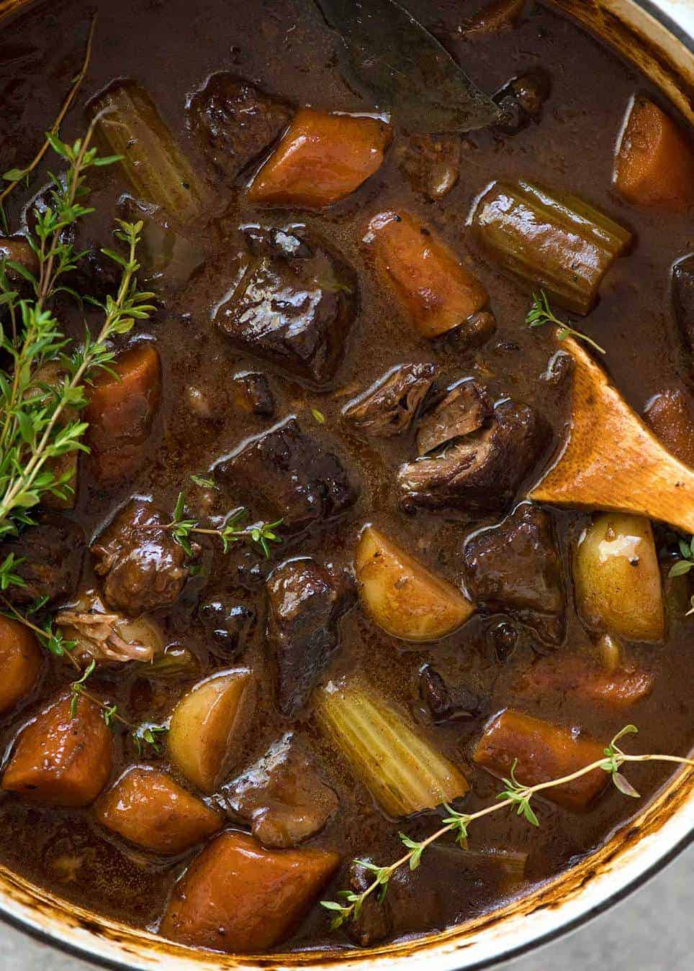
Ingredients
2.4lb chuck beef , cut into 3½" cubes (Note 1)
1 tsp each salt and pepper
3 tbsp olive oil , divided
1 large onion , halved then cut into 2/5" slices
4 garlic cloves , minced
3 carrots , cut into 1" pieces on the diagonal
2 celery stalks , cut into 1" pieces
1/3 cup flour
3 cups beef broth / stock , salt reduced
2 cups red wine , bold and dry (Cab Sauv, Burgundy, Merlot) (Note 2)
2 tsp Worcestershire Sauce
2 tbsp tomato paste
2 bay leaves , fresh or dried
4 sprigs thyme
14 oz baby potatoes , halved
More salt and pepper , to taste.
Instructions
- Sprinkle beef with salt and pepper.
- Heat 1 1/2 tbsp oil in a large, heavy based casserole pot over high heat until just
starting to smoke.
- Add 1/3 of the beef and brown aggressively all over - about 4 minutes. Remove to
bowl, repeat with remaining beef, adding more oil if required.
- Turn down heat to medium high. Add 1 tbsp oil if required. Add onion and garlic,
cook for 2 minutes until onion is softened slightly and golden on the edge.
- Add carrot and celery, stir for 1 minute to coat in flavours.
- Sprinkle flour evenly across surface, then stir to coat.
- Add broth, red wine, tomato paste and Worcestershire sauce. Stir to dissolve tomato
paste and flour into liquid.
- Add cooked beef (including any juices), thyme, bay leaf and potato. Stir. Water level
should almost fully cover everything (see video), if not, add a touch of water.
- Bring to simmer, then adjust heat to low / medium low so it's simmering gently.
(Note 3 for other cooking methods)
- Cover and cook for 1 hour 45 minutes or until beef is pretty tender (check with 2
forks at 1.5 hrs).
- Remove lid and simmer for further 30 minutes or until sauce reduces slightly. It
should be like a thin gravy (see video) and beef should now be very tender.
- Season to taste with salt and pepper.
- Serve over creamy mashed potato with a sprig of fresh thyme for decoration or a
sprinkle of parsley (Note 4).

Recipe Notes:
1. Beef - Any slow cooking cut of beef will work. Chuck is my favourite from a texture and fat % point. Brisket and gravy beef will also work great.
2. Red wine adds to the depth of flavour of the sauce. Use a good value full-bodied red wine, like cabernet sauvignon or merlot. Shiraz is ok too. No need to use expensive wine for slow cooked recipes like this (and the New York Times agrees). Use discount end of bin specials. Pinots not suitable, too light.
99% of the alcohol in the red wine evaporates during cooking. The sauce does not taste winey at all, it completely transforms.
If you can't consume alcohol, substitute with more beef broth and 2 tsp brown sugar.
3. Other Cooking Methods:
- OVEN: Cover and bake for 2 1/2 hours at 300°F. Remove lid then return to oven for a further 30 - 45 minutes to reduce sauce.
- SLOW COOKER: Reduce beef broth by 1 cup. After you finish step 7, transfer everything into the slow cooker. Add splash of water into pot, bring to simmer, scraping the bottom of the pot, then tip it all into the slow cooker. Add remaining ingredients, per recipe. Cook on low for 8 hours. Remove lid and let it rest for 15 minutes before serving, stirring every now and then (the sauce will thicken slightly).
- PRESSURE COOKER: Follow slow cooker instructions, except cook on HIGH for 40 minutes.
- INSTANT POT*: Follow steps 1 to 7 of the recipe using the sauté function, then proceed with either the Slow Cooker or Pressure Cooker function. Simmer with the lid off at the end if you want to thicken the sauce slightly.
4. Other serving suggestions: with warm crusty bread for dunking (try this easy rustic no-yeast Irish Bread), polenta, rice, cauliflower mash (low carb option), or other mashed root vegetables (carrot, parsnip, pumpkin, sweet potato).
5. STORAGE / LEFTOVERS - Refrigerate or freeze, then thaw before reheating on the stove or microwave. Tastes even better the next day because the flavours develop even
more.
6. Nutrition per serving, assuming 6 servings. I like to trim excess fat from the beef but this is not factored into the nutrition. Stew only - not mashed potato.

